# Laser ToF Sensor

# Introduction

The purpose of this document is to describe the Laser Time of Flight (ToF) Sensor block of the Wearable Sensor for the Blind ECE Senior Capstone Project to other engineers with enough detail such that they would be able to reproduce and test this block using only this document as reference. The Laser ToF block is implemented using a band of many VL53L0X ToF Ranging Sensor from ST Microelectronics on custom-built PCBs. Included in this document are an overview of the block, a schematic and wiring diagram, the properties of the interfaces with the other blocks in the system and testing procedures for each, and reasoning for why this design is the best solution for this block.

# Block Overview

The Laser ToF Sensor block will provide the distance to the nearest object in eight 45° zones around the user to the system, which will use that information to set the system haptic feedback module that will convey that distance information to the user. The measurements taken need to be fast and accurate, so that the user can quickly and confidently navigate around obstacles in their environment. Fig. 1 below shows the black box diagram of the system. *otsd_lsr_tf_snsr_envin* represents the environmental input to this block, namely the distance to the nearest objects. *lsr_tf_snsr_cntrllr_cd_data* represents the I2C input from the microcontroller, which triggers measurements for the sensors and programs the ranging profile. *pwr_spply_lsr_tf_snsr_dcpwr* represents the connection to the power supply, which is regulated to 3.3V, and should draw about 30mA per sensor during measurements. And finally, *cntrllr_cd_lsr_tf_snsr_data* represents the I2C data output from this block to the microcontroller. All the properties for these interfaces can be found in Table I. Sean Sylwester completed this block.

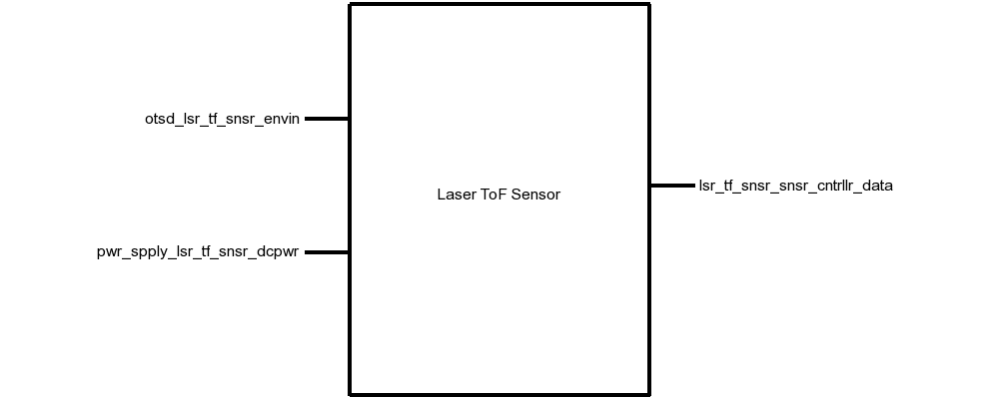

# Fig. 1. Black Box Diagram of the Laser ToF Sensor Block

# Table I. Laser Tof Sensor Block Interfaces And Properties

| **Name** | **Properties** |
| --- | --- |
| *otsd_lsr_tf_snsr_envin* | 1. Other: Accuracy: 12% 2. Other: Range: 0.4m(Black) 1m(White) 3. Other: Angle: 5° 4. Other: Measurement Time: 60ms |
| *lsr_tf_snsr_snsr_cntrllr_data* | 1. Datarate: 100kHz 2. Messages: Sensor Data 3. Other: Measurement Time: 60ms 4. Protocol: I2C |
| *pwr_spply_lsr_tf_snsr_dcpwr* | 1. Inominal: 35µA ± 10% per sensor (between measurements) 2. Ipeak: 30mA per sensor (during measurement) 3. Vmax: 3.5V 4. Vmin: 2.6V |

# Verification

This section details the testing procedures to verify every property listed in Table I. All tests must be passed successfully before this block will be integrated into the rest of the system. Testing will be completed using a single VL53L0X sensor board.

## Power and Communication Testing

This test will verify the power requirements for this block on the *pwr_spply_lsr_tf_snsr_dcpwr* interface, and the communication requirements on the *cntrllr_cd_lsr_tf_snsr_data* and *lsr_tf_snsr_cntrllr_cd_data* interfaces.

1. Connect a VL53L0X sensor to a DC power supply that can display current, set to 2.6V, via the *pwr_spply_lsr_tf_snsr_dcpwr* interface.
2. Connect a microcontroller using I2C at 100kHz to the *otsd_lsr_tf_snsr_envin* interface.
3. Load a test program on the microcontroller than takes a measurement for 200ms, then idles for 200ms.
4. Note the current displayed on the DC power supply during a measurement, and during idle.
5. Repeat steps 1-4 with the DC power supply set to 3.5V.

PASS: This test passes if the current draw never exceeds 30mA, and if the I2C interface communication links at 100kHz.

[Link to Video](https://drive.google.com/open?id=1DZrGBg1QwSPyPH-QyeYReq4xZ42xtdXK)

## Measurement

This test will verify the measurement requirements for this block on the *otsd_lsr_tf_snsr_envin* interface.

1. Connect a VL53L0X sensor to a DC power supply set to 2.8V via the *pwr_spply_lsr_tf_snsr_dcpwr* interface.
2. Connect a microcontroller using I2C at 100kHz to the *otsd_lsr_tf_snsr_envin* interface.
3. Load a test program on the microcontroller than takes a measurement for 60ms, then prints out the distance measurement, then idles for 40ms.
4. Place a white object 1m directly in front of the sensor and note if the sensor detects the object.
5. Place a black object 0.4m directly in front of the sensor and note if the sensor detects the object.
6. Place a white object 30cm away, and 3cm off-center (5°) and note if the sensor detects the object.
7. Place a white object 30cm directly in front of the sensor and note if the distance measurement is within 10% of 30cm.

PASS: If the measurements complete in less than 60ms, objects in steps 4, 5, and 6 were detected, and the object in step 7 was detected within 10%.

[Link to Video](https://drive.google.com/open?id=1DZrGBg1QwSPyPH-QyeYReq4xZ42xtdXK)

# Design

The schematic in Fig. 2 presents this block’s wiring diagram, including the interfaces of this block to the rest of the system. Fig. 3 shows the schematic for the custom-build sensor interface PCB, and Fig. 4 shows the physical layout of this PCB.

This block is implemented using 30 VL53L0X Laser ToF Sensors mounted on a headband to achieve the 360° sensing system requirement. All the sensors are connected to the same I2C (SDA and SCL) bus. Since all the sensors have the same default I2C address on startup, they need to be enabled one-at-a-time to reprogram each address to be unique. This is done with a MAX6895 Delay IC, which propagates a boot signal through each sensor in turn with a 30ms delay. In the 30ms window after a sensor boots, that sensor will be the only one on the I2C bus with the default address, so it can be reprogramed without any conflict.

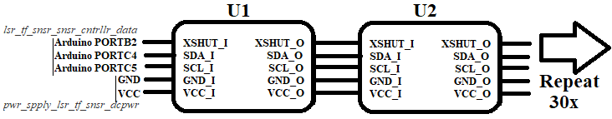

Fig. 2. Wiring Diagram for the Laser ToF Sensor Block

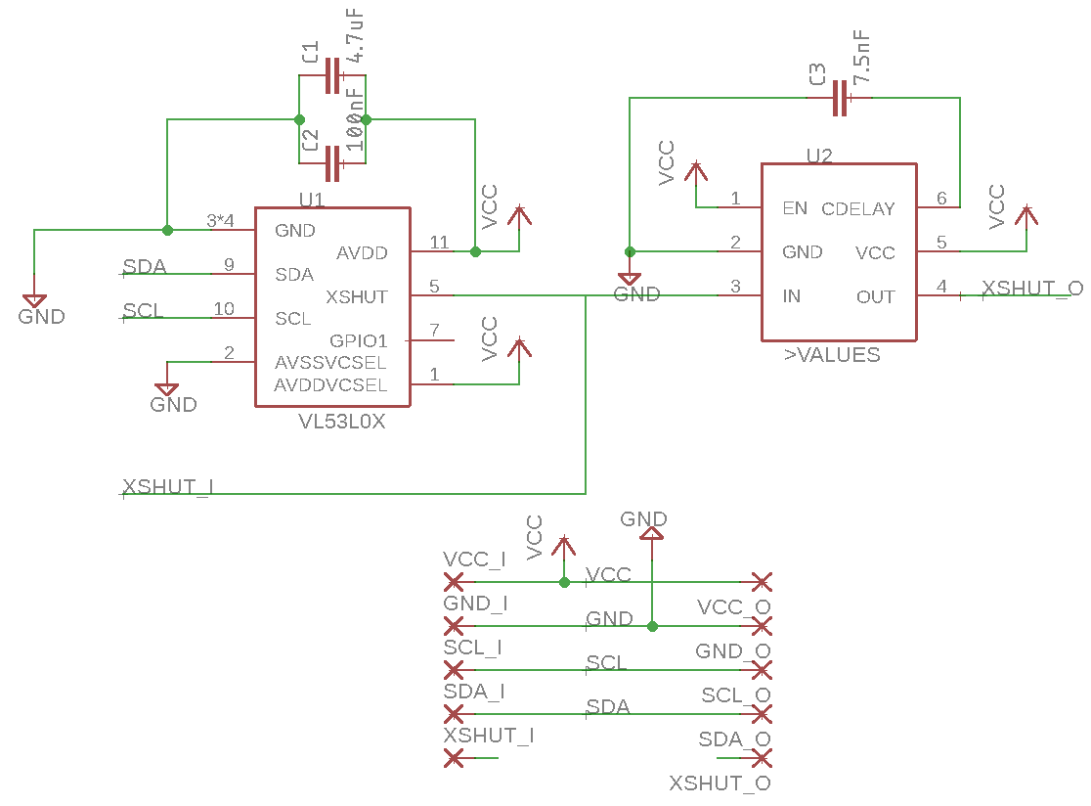

Fig. 3. VL53L0X Interface PCB Schematic

The values for smoothing capacitors C1 and C2, 4.7µF and 100nF, respectively, were indicated in Figure 3 in the VL53L0X datasheet [8]. Capacitor C3 was chosen to set the delay of the MAXIM Delay IC to be 30ms, which was calculated using the equation tDELAY = [CCDELAY x 4.0 x 106 + 40µs] from page 7 of the MAX6895 datasheet [9].

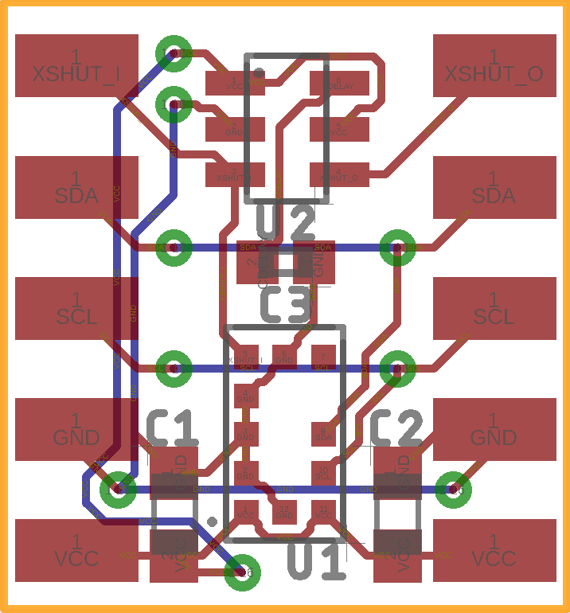

Fig. 4. VL53L0X Interface PCB Layout

## Design Validation

For this block, the VL53L0X sensor was used because it fits the low cost, low power, medium range, high accuracy, and fast performance that this project required of the Laser ToF Sensor block. Table II below validates all the system properties using the VL53L0X Datasheet.

Table II. Interface Property Validation For The Laser ToF Sensor Block

| Property | Validation |
| --- | --- |
| *otsd_lsr_tf_snsr_envin* | |
| **Other:** Accuracy: 12% | Table 12 of the VL53L0X Datasheet states that the worst-case accuracy is 12% [8]. |
| **Other:** Range: 0.4m(Black) 1m(White) | Table 11 of the VL53L0X Datasheet states that the minimum range indoors is 1.2m for a white object, and 0.7m for a grey object [8]. |
| **Other:** Angle: 5° | VL53L0X Datasheet states that the FOV of the sensor is 25° [8]. |
| **Other:**Measurement Time: 60ms | Table 13 of the VL53L0X Datasheet states that minimum timing budget is 20ms [8]. |
| *lsr_tf_snsr_snsr_cntrllr_data* | |
| **Datarate:**100kHz | Table 3 of the VL53L0X Datasheet states that the maximum I2C operating frequency is 400kHz [8] |
| **Messages:** Sensor Data | Section 2 of the VL53L0X Datasheet states that Address Programming, Measurement Trigger, and Measurement Read commands can be sent over I2C [8]. |
| **Other:** Measurement Time:60ms | Table 13 of the VL53L0X Datasheet states that minimum timing budget is 20ms [8]. |
| **Protocol:** I2C | Section 3 of the VL53L0X Datasheet states that I2C is the control interface required [8]. |
| *pwr_spply_lsr_tf_snsr_dcpwr* | |
| **Inominal:**20µA ± 10% per sensor (between measurements) | Table 9 of the VL53L0X Datasheet states that the inter-measurement current consumption is 16µA [8]. |
| **Ipeak:**30mA per sensor (during measurement) | Table 9 of the VL53L0X Datasheet states that the measurement current consumption is 19mA [8]. |
| **Vmin:**2.6V | Table 9 of the VL53L0X Datasheet states that the minimum operating voltage is 2.6V [8]. |
| **Vmax:**3.5V | Table 9 of the VL53L0X Datasheet states that the minimum operating voltage is 3.5V [8]. |

## Bill of Materials

Table III. Bill of Materials for the Laser ToF Sensor Block

|  |  |  |  |  |  |  |
| --- | --- | --- | --- | --- | --- | --- |
| **Reference Designator** | **Value** | **Manufacturer** | **Manufacturer Part Number** | **Suppliers** | **Quantity** | **Unit**  **Price** |
| C1 | 4.7uF | Taiyo Yuden | LMK107BJ475KA-T | Mouser | 30 | $0.18 |
| C2 | 100nF | Vishay | VJ0603Y104KXXCW1BC | Mouser | 30 | $0.12 |
| C3 | 7.5nF | Murata | GRM155R71E752JA01D | Mouser | 30 | $0.10 |
| U1 | VL53L0X | STMicroelectronics | VL53L0CXV0DH/1 | Mouser | 30 | $5.30 |
| U2 | MAX6895  Delay IC | MAXIM | MAX6895AAZT+T | Mouser | 30 | $2.00 |

1. STMicrolectronics, “World smallest Time-of-Flight ranging and gesture detection sensor,” VL53L0X datasheet, May 2016
2. MAXIM, “Ultra-Small, Adjustable Sequencing/ Supervisory Circuits,” MAX6895–MAX6899 datasheet, Mar. 2013

# PCB

# Introduction

The purpose of this document is to describe the PCB Block of the Wearable Sensor for the Blind ECE Senior Capstone Project to other engineers with enough detail such that they would be able to reproduce this block using only this document as reference. Included in this document are an overview of the block, a schematic and layout diagram, and a complete bill of materials for the PCB.

# Block Overview

The PCB block links together all the individual components of the system. It provides the necessary connectors to wire together the system processing blocks to the sensor blocks and haptic feedback block. It will also hold the 3.3V regulator, which will power every component in the system. Fig. 1 below shows all the connectors needed on the PCB. This block was completed by Sean Sylwester.

Microcontroller Pinout

Bluetooth Pinout

Ultrasonic Sensor Pinout

Laser ToF Sensor Pinout

Magnetometer Pinout

Battery Pinout

3.3V Regulator

# Fig. 1. Block Diagram of the PCB Block

## Schematic

Fig. 2 below shows the schematic of the PCB corresponding to the block diagram shown in Fig. 1.

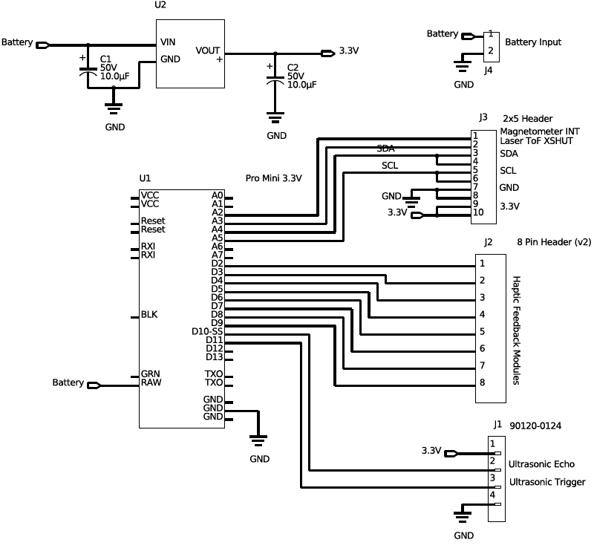

Fig. 2. PCB Schematic



a

## PCB Artwork

Note: The layout editor used does not have background color settings. The color will be fixed for the final draft of this block description. Fig. 3 and Fig. 4 below show the physical layout of the PCB according to the schematic shown in Fig. 2.

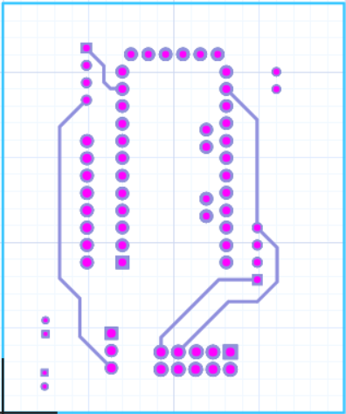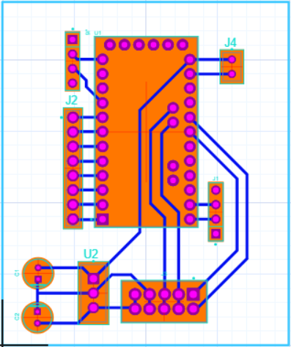[Link to Gerber Files](https://drive.google.com/open?id=171usb4jrnoYiYgdBSN0O6X7ydCBb0Gc1)

Fig. 3. PCB Layout Top

Fig. 4. PCB Layout Bottom



## Bill of Materials

Table I. Bill Of Materials For The Microcontroller Block

| Reference Designator | Description | Manufacturer | Manufacturer Part Number | Suppliers | Package | Quantity | Price |
| --- | --- | --- | --- | --- | --- | --- | --- |
| C1 C2 | ALUMINUM ELECTROLYTIC CAPACITORS | AVX | UKL1H100KDDANA | Digi-Key | RADIAL | 2 | $0.42 |
| J1 | Single Row Straight Pin Header | Molex | 90120-0124 | Digi-Key | 2.54mm | 1 | $0.01 |
| J2 | 8 Pin Header | Generic Headers | 8 Pin Header (v2) | Digi-Key | 2.54mm | 1 | $0.02 |
| J3 | 2x5 Header | Generic | 2x5 Header | Digi-Key | 2.54mm | 1 | $0.04 |
| J4 | 2x1 Male Header | Generic | Male Header - 2 pin | Digi-Key | 2.54mm | 1 | $0.01 |
| U1 | Arduino Pro Mini | Arudino | Pro Mini 3.3V | Digi-Key | Pro Mini | 1 | $14.99 |
| U2 | Standard | Texas Instruments | UCC283T-5 | Digi-Key | TO220 | 1 | $7.88 |

## Approval Log

Table 2 below records the approval signatures for the PCB’s schematic, layout and bill of materials. The PCB was not completed for this block description draft, so the table is currently blank.

Table 2. PCB Approval Log

| Schematic Approved | Signature: | Date: |
| --- | --- | --- |
| **PCB Approved** | Signature: | Date: |
| **Bill of Materials Complete** | Signature: | Date: |

# Ultrasonic Sensor

# Introduction

The purpose of this document is to describe the Ultrasonic Sensor block of the Wearable Sensor for the Blind ECE Senior Capstone Project to other engineers with enough detail such that they would be able to reproduce and test this block using only this document as reference. The Ultrasonic Sensor block is implemented using a JSN-SR04T waterproof ultrasonic module. Included in this document are an overview of the block, a schematic and wiring diagram, the properties of the interfaces with the other blocks in the system and testing procedures for each, and reasoning for why this design is the best solution for this block.

# Block Overview

The Ultrasonic Sensor block will provide the distance to the nearest object in the direction that the user’s head is pointing to the system, which will use that information to set the system haptic feedback module that will convey that distance information to the user. The measurements taken need to be fast and accurate, so that the user can quickly and confidently navigate around obstacles in their environment. The sensor will determine the Fig. 1 below shows the black box diagram of the system. *otsd_ultrsnc_snsr_envin* represents the environmental input to this block, namely the distance to the nearest object. *ultrsnc_snsr_snsr_cntrllr_data* represents the sensor data link to the microcontroller. And finally, *pwr_spply_ultrsnc_snsr_dcpwr* represents the connection to the power supply, which is regulated to 5V, and should draw about 5mA during measurements. Sean Sylwester completed this block.

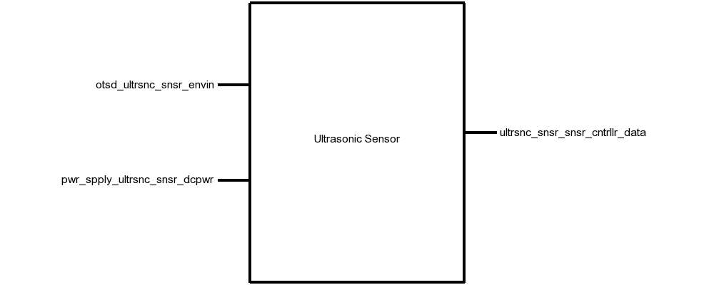

Fig. 1. Black Box Diagram of Ultrasonic Sensor Block

Table I. Display Block Interfaces And Properties

| Interface | Properties |
| --- | --- |
| *otsd_ultrsnc_snsr_envin* | 1. Other: Accuracy: 10cm 2. Other: Angle: 37.5° 3. Other: Range: 20-500cm |
| *ultrsnc_snsr_snsr_cntrllr_data* | 1. Messages: Object Distance 2. Other: Measurement Time: <38ms 3. Other: Pulse Voltage: 5V 4. Protocol: TTL |
| *pwr_spply_ultrsnc_snsr_dcpwr* | 1. Inominal: 5mA ± 10% 2. Ipeak: 30mA 3. Vmax: 5.5V 4. Vmin: 3V |

# Verification

This section details the testing procedures to verify every property listed in Table I. All tests must be passed successfully before this block will be integrated into the rest of the system.

## Measurement Testing

This test will verify the measurement requirements for this block on the *otsd_ultrsnc_snsr_envin* interface.

1. Connect the JSN-SR04T ultrasonic sensor to a DC power supply set to 5V via the *pwr_spply_ultrsnc_snsr_dcpwr* interface.
2. Connect the JSN-SR04T Echo and Trigger pins to a microcontroller.
3. Load a test program on the microcontroller that continuously triggers a measurement, reads the sensor data, and prints the result to a computer.
4. Place an object 20cm directly in front of the sensor and note if the sensor detects the object.
5. Place an object 500cm directly in front of the sensor and note if the sensor detects the object.
6. Place an object 100cm away, and 75cm off-center (37.5°) and note if the sensor detects the object.
7. Place an object 100cm directly in front of the sensor and note if the sensor measurement is within 10cm of 100cm.

PASS: If the measurement completes in less than 38ms, objects in steps 4, 5, and 6 were detected, and the object in step 7 was detected within 10cm.

[Link to Video](https://drive.google.com/open?id=1ZqxbQ-ia4OiUPHisv6PiKTbCvmjG8xuT)

*Power Testing*

This test will verify the power requirements for this block on the *pwr_spply_ultrsnc_snsr_dcpwr* interface.

1. Connect the JSN-SR04T ultrasonic sensor to a DC power supply set to 5.5V via the *pwr_spply_ultrsnc_snsr_dcpwr* interface.
2. Connect the JSN-SR04T Echo and Trigger pins to a microcontroller.
3. Trigger a measurement by pulling the Trigger pin to logic HIGH for 10µs.
4. Note the current displayed on the DC power supply during a measurement, and during idle.
5. Repeat steps 1-4 with the DC power supply set to 3V.

PASS: If the current never exceeds 30mA, a pulse on the Echo pin is returned with the 3V and 5.5V supplies.

[Link to Video](https://drive.google.com/open?id=1ZqxbQ-ia4OiUPHisv6PiKTbCvmjG8xuT)

# Design

The schematic in Fig. 2 presents this wiring diagram for the JSN-SR04T sensor used in this block, including the interfaces of this block to the rest of the system. The timing diagram in Fig. 3 shows the input and output data from the block. Table II provides validation for each of the properties listed in Table I using the JSN-SR04T datasheet.

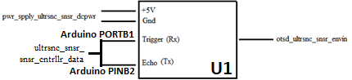

Fig. 2. Wiring Diagram for the Ultrasonic Module Block

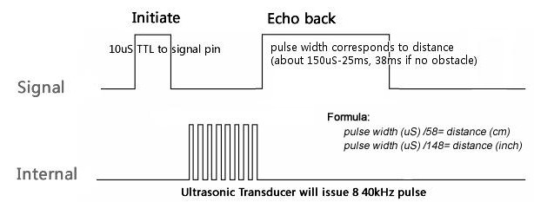

Fig. 3. Measurement Timing Diagram for the Ultrasonic Module Block

# Design Validation

For this block, the JSN-SR04T ultrasonic sensor was used. This sensor was chosen because it fits the water resistance, measurement distance, accuracy, and angle of detection metrics required of the Ultrasonic Sensor Block. Table II below validates each property listed in Table I. Note that the sensor used in the JSN-SR04 is identical to the one used in the HC-SR04. Neither of these have a datasheet, but the HC-SR04 has a reference document with enough information to validate these properties.

Table II. Interface Property Validation For The Ultrasonic Sensor Block

| Property | Validation |
| --- | --- |
| *pwr_spply_ultrsnc_snsr_dcpwr* | |
| Min Voltage: 3 V | The HC-SR04 datasheet says that the minimum supply voltage is 3 V [13] |
| Max Voltage: 5.5 V | The HC-SR04 datasheet says that the maximum supply voltage is 5.5 V [13] |
| Nominal Current: 5mA | The HC-SR04 datasheet says that the nominal working current nominal is <8mA [13] |
| Peak Current: 30mA | The HC-SR04 datasheet says that the quiescent current is less than 2 mA [13] |
| *otsd_ultrsnc_snsr_envin* | |
| Range: 20 cm - 500cm | The HC-SR04 datasheet says that the distance range is 20-500cm [13] |
| Range accuracy: 10cm | The HC-SR04 datasheet says that the distance measurement is accurate to ±0.3cm [13] |
| Angle: 15° | The HC-SR04 datasheet says that angle of the ultrasonic is at least 15° [13] |
| *ultrsnc_snsr_snsr_cntrllr_data* | |
| Pulse Protocol: TTL | The HC-SR04 datasheet says that a Time-to-Life (TTL) signal is used to encode the distance measurement [13] |
| Other: Measurement Time: <38ms | The HC-SR04 datasheet says that the width of the TTL signal is 150µs to 25ms, and 38ms if no object is detected [13] |
| Pulse Voltage: 5 V | The HC-SR04 datasheet says that the Echo and Trigger pins require a 5V pulse signal [13] |
| Messages: Sensor Data | The HC-SR04 datasheet says that a Time-to-Life (TTL) signal is used to encode the distance measurement [13] |

# Bill of Materials

Table III. Bill of Materials for the Ultrasonic Sensor Block

| Reference Designator | Description | Manufacturer | Manufacturer Part Number | Suppliers | Quantity | Price |
| --- | --- | --- | --- | --- | --- | --- |
| U1 | Ultrasonic Sensor | JSN | JSN-SR04T | Digi-Key | 1 | $15.39 |

1. ITeadStudio, “Ultrasonic Ranging Module : HC-SR04,” HC-SR04 datasheet, Mar. 2011

# Revision History

|  |  |  |  |  |
| --- | --- | --- | --- | --- |
| **Date** | **Section** |  | **Editor** | **Description of Change** |
| 1/21/18 | Laser ToF Sensor Block Description |  | Sean Sylwester | Updated some wording, updated the interfaces and properties due to a change in our block diagram |
| 1/21/18 | Ultrasonic Sensor Block Description |  | Sean Sylwester | Section Created |
| 1/21/18 | PCB Block Description |  | Sean Sylwester | Section Created |
| 2/7/18 | Laser ToF Sensor Block Description |  | Sean Sylwester | BoM, and design and validation sections updated. |
| 2/7/18 | Ultrasonic Sensor Block Description |  | Sean Sylwester | BoM, and validation section updated |
| 2/7/18 | PCB Block Description |  | Sean Sylwester | BoM updated and figure background colors changed from black to white |

# Process Memo

Since the last submission, I completely changed the Laser ToF Sensor block, so much of the block description needed to be updated. The interfaces were the same, but I switched from using an Adafruit board to creating my own PCB so I needed to add detail to the design section. In all three blocks I updated the BoM according to the specifications, fixed several figures according to TA feedback, and added references. I didn’t get any feedback suggesting changes to anything else, so most of the block descriptions stayed the same.